
Thriving, Helpful, & Wild Dandelions
Simple Recipes & Uses that Benefit You & the Pollinators
Copyright © 2025 by Laura Warner
All rights reserved.
No part of this publication may be reproduced, distributed, or transmitted in any form or by any means, including photocopying, recording, or other electronic or mechanical methods, without the prior written permission of the publisher, except in the case of brief quotations embodied in critical reviews and certain other noncommercial uses permitted by copyright law.
This book is published by The Honest Whisper.
Disclaimer:
This book is intended for informational and educational purposes only. The recipes, advice, and tips contained within are based on the author's personal experience and research. Always consult with a qualified health professional before making any dietary changes or using dandelions for health purposes. The author and publisher are not liable for any adverse reactions, effects, or consequences resulting from the use of the recipes or suggestions in this book.
Artwork Credit:
Images generated with the use of artificial intelligence.
Welcome
My name is Laura Warner, and as the founder of The Honest Whisper, I am delighted to offer you this complimentary book. As a vegan, I am constantly seeking ways to align my life with my deepest values—to respect nature and animals. This book is one of those ways. For as long as I can remember, dandelions have held a special place in my life. Their simple beauty and resilience inspired me so much that I even incorporated them into The Honest Whisper's logo.
In this book, you'll discover the wild secret of the dandelion and the benefits of embracing them in your kitchen, home, and garden. Not only will you find delicious recipes and practical uses to try, but you'll also see how they help support a vital food source for bees and other pollinators. Each page is designed to help you make a positive impact on your own health and the health of the planet. All while recognizing the value of dandelions. I hope this book inspires you to appreciate dandelions as much as I do.
- Laura

Introduction

The Golden Connection: From Garden to Bee to You

Masters of Survival
Dandelions are often labeled as a pesky weed, an unwanted invader to be removed from lawns and gardens. Many people remove dandelions from their lawns, but in regions like North America and Europe, they are a vital early food source for native pollinators.

Their widespread presence is a quiet but powerful contribution to the local ecosystem. To reject the label of "weed" is to challenge the very notion of what is considered valuable versus what is undesirable, a lesson that extends far beyond the garden.
To appreciate a dandelion's right to exist is to understand a larger lesson in liberation. This simple act parallels the fights for animal and environmental rights, both of which challenge the view that some beings exist solely for our use. By seeing the dandelion as a vital part of its ecosystem, we begin to understand that true liberation for any one being is intertwined with the liberation of all.

The World's Most Successful Traveler
The dandelion’s current status as awidespread "weed" is actually a testament to its extraordinary evolutionary success. This plant is a global citizen, thriving not just in lawns but in nearly every temperate climate and soil condition worldwide. Its resilience is built into its design, from its deep, water-seeking taproot that shrugs off drought to its ability to bloom and set seed incredibly fast, sometimes completing the entire cycle in a matter of days. Understanding this resilience can shift the perception from pest to powerhouse, and truly appreciate its ability to endure.
The dandelion seed-head—the white "puffball"—is one of nature's most sophisticated dispersal systems. Each tiny seed is attached to a parachute of fine hairs (a pappus) that allows it to float on air currents for distances of up to five miles (eight kilometers), or even further under ideal conditions! Furthermore, the seeds do not require cross-pollination to be viable, as most dandelions reproduce asexually (apomixis). This combination of long-distance, self-reliant travel ensures that once a dandelion lands in a suitable spot anywhere in the world, it can immediately establish a genetically identical clone, guaranteeing the species' survival.
A Lesson in Unrecognized Value
For many, the dandelion is an unwanted intruder, yet it persists, quietly performing vital work for the soil and pollinators. In this way, the dandelion offers an inspiring lesson: True value is not determined by how loudly you're praised, but by the essential function you perform. If you or someone you know feels unappreciated or overlooked—like the vibrant bloom that’s treated as a pest—remember the dandelion. It maintains its purpose, nourishes its community, and ultimately cannot be erased. Appreciating the dandelion means acknowledging that strength and value often thrive in the places society labels as common or inconvenient.
The Golden Connection
The "Golden Connection" is a simple pact with nature. By allowing dandelions to bloom in early spring, you provide a crucial first food for hungry pollinators. Once mid-spring arrives and other flowers are abundant, you can then mindfully harvest them for yourself, knowing you've already helped the planet. This simple, two-part act creates a beautiful, symbiotic relationship that benefits the entire ecosystem.
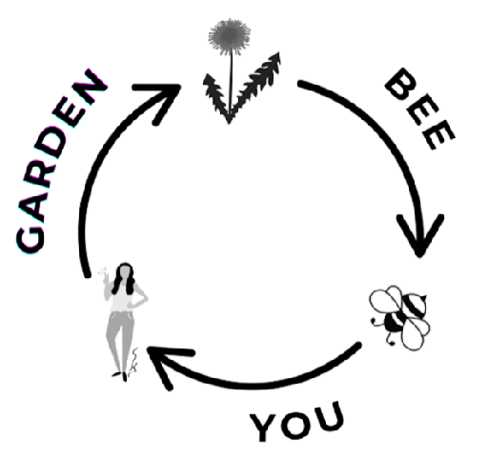
Did you know dandelions are the ultimate self-sufficient ecosystem starter?
Dandelions creates a perfect cycle of mutual benefit, even providing its own fertilizer. As its deep taproot draws minerals like calcium up from the subsoil, the leaves become nutrient-rich food for both bees (via protein-packed pollen) and you (via nutrient-dense greens). When the plant is eventually mowed or harvested, these essential minerals are released back onto the topsoil, acting as a natural, free fertilizer for the surrounding grass and plants, effectively making the dandelion a three-in-one gift: soil conditioner, pollinator feed, and human superfood.
Garden
Dandelions are remarkably easy to grow. Whether you let them grow wild in your yard or plant them in a garden or pot, these resilient, low-maintenance plants thrive with little attention. You can even find unique varieties like pink dandelions. No matter the variety, it's crucial to harvest dandelions from a place that is free of pesticides, herbicides, and away from roadsides.

Did you know dandelions were originally grown as a food crop?
The most surprising fact for many modern gardeners is that the common dandelion (Taraxacum officinale) was not brought to North America as an accidental weed, but as a deliberate food and medicinal crop. Native to Eurasia, the plant was intentionally carried across oceans by European settlers, possibly arriving as early as the 1620s on the Mayflower or soon after.
Settlers valued it as a reliable, highly nutritious addition to their kitchen gardens, treating it more like a cultivated green than a nuisance. To manage its characteristic bitterness, historical gardeners employed a technique called blanching. This involved cutting off the outer leaves and covering the remaining plant with soil or an overturned pot. This process starved the new growth of sunlight, resulting in pale, tender, and much less bitter leaves that were preferred for salads and cooking. For centuries, the dandelion was revered as a powerful tonic and a crucial source of vitamins and minerals, a history that has only been overshadowed since the 20th century with the rise of the manicured lawn.
Bee
Dandelions are incredibly important for pollinators, especially in early spring in North America and parts of Europe. Their nectar and pollen provide important food for bees, butterflies, and other helpful insects when food is hard to find.

These pollinators are crucial to the planet's health. They help fertilize most of the world's flowering plants. This includes many food crops. They support biodiversity and help plants reproduce. These plants are the base of many ecosystems. Without them, our food supply and natural landscapes would suffer.

Did you know dandelion flowers are a protein powerhouse for bees?
Dandelions provide more than just sugar for energy. While the nectar gives bees a vital carbohydrate boost, the dandelion's pollen is exceptionally rich in protein, which is crucial for developing larvae and sustaining a growing bee colony in the early season. For emerging queen bumblebees, in particular, this high-quality protein is necessary to successfully lay eggs and raise the first generation of worker bees. This makes the common dandelion a complete early-spring meal—a caloric energy source and a protein-packed building block—essential for jumpstarting pollinator populations for the rest of the year.
You
Once the abundance of mid-spring arrives and pollinators have found alternative food sources, the dandelions are ready to share their gifts with you. Dandelions are a great source of vitamins and are rich in antioxidants. They help support liver health and act as a natural diuretic. You can harvest them to create delicious dishes, brew comforting teas, or even craft unique herbal remedies.


Did you know dandelions can be more nutritious than garden greens?
Dandelion greens can be nutritionally superior to many common vegetables found in the produce aisle. A single cup of raw dandelion greens contains significantly more vitamins A and K than a similar serving of spinach or kale! Specifically, they are a phenomenal source of Vitamin K, which plays a vital role in blood clotting and bone health, and they are loaded with Vitamin A (as beta-carotene). This exceptional concentration of micronutrients is why early settlers and many cultures around the world relied on this "weed" as a powerful seasonal tonic to replenish nutrients depleted over the winter months.

About

Dandelion Anatomy: A Guide from Root to Flower

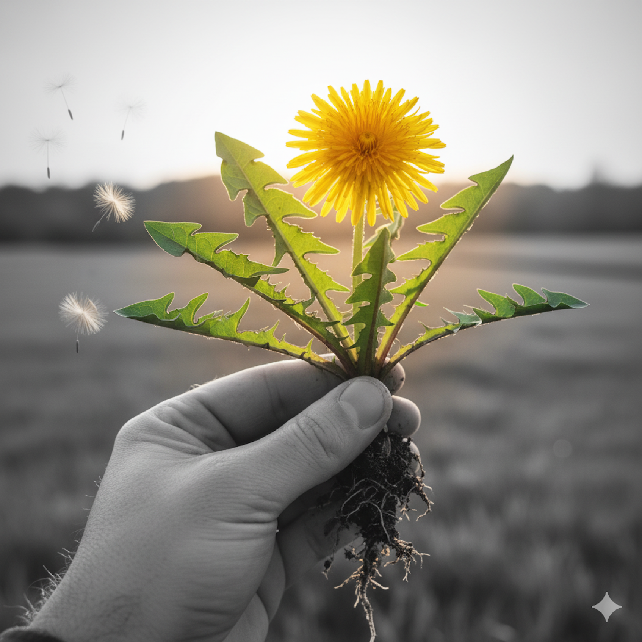
Dandelion Anatomy
You're about to explore one of nature's most special plants, the mighty dandelion. Don't worry—this isn't a test! Sit back, relax, and get ready to discover the magic hidden in every single part of this versatile flower. From its deep, powerful roots to its sunny blossoms and fleeting puffballs, we'll show you how to make the absolute most of this humble, yet beneficial, backyard hero.
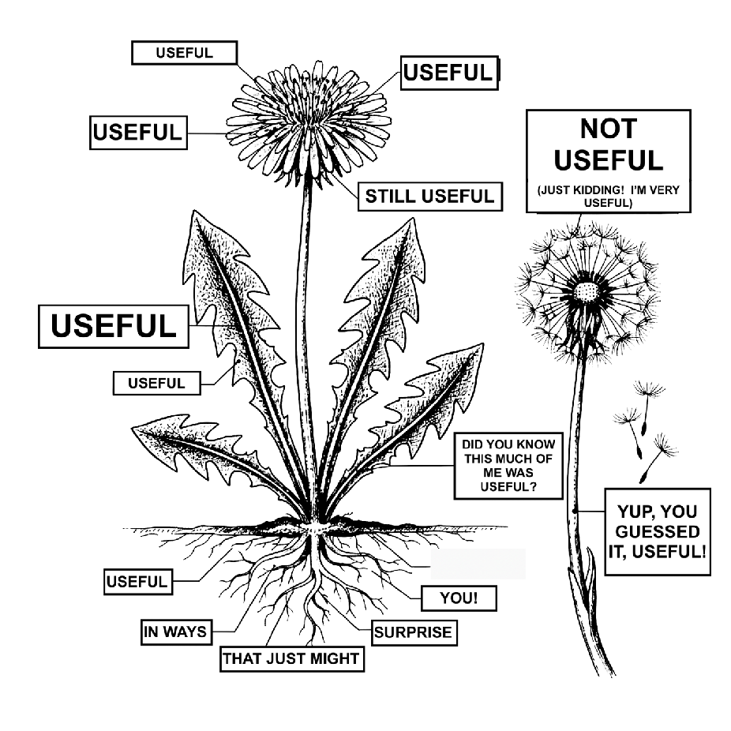
The dandelion's structure—from its deeply anchored taproot, which mines minerals from the soil, to its sun-sensitive flower head, which maximizes pollination—is engineered for absolute survival. Understanding its parts helps us not only forage better but appreciate the ingenuity of this plant that so many dismiss as a weed. Crucially, every single part of the dandelion—root, leaf, and flower—is incredibly useful for food, wellness, creativity, culture and much more.
Dandelion Flowers

For Nature: The dandelion flower is a lifeline. As one of the first flowers in spring, its bright yellow head gives important nectar and protein-rich pollen. This helps bees, butterflies, and other pollinators when few other plants are blooming. It's a key food source for over a hundred species of insects and even provides sustenance for birds that eat its seeds.
For Cooking: The sunny flowers offer a delicate, sweet flavour. You can separate the petals and sprinkle them on salads for colour. You can also mix them into pancake batter for a fun and healthy breakfast. The entire flower head can be dipped in a light batter and fried as a fritter. Their most famous use is making dandelion wine. This drink is light and aromatic, capturing the essence of spring.
For Art & Culture: Beyond the kitchen, dandelions are a symbol of creativity and tradition. The bright yellow petals can be used to make a dye for textiles and even a naturally-coloured ink for art projects. In the folklore of some regions, the dandelion's seeds are believed to carry wishes on the wind, representing hope, dreams, and the power of a simple breath.
For Wellness: The flowers are rich in antioxidants and contain compounds that may help support vision health. Traditionally, the bright yellow petals—which are slightly sweet—have been used to create infusions or syrups known for their soothing, mild properties. Consuming the flowers is often viewed as a simple way to bring the nutritional and energetic benefits of spring directly into the body. They are also thought to have a mild calming effect when consumed as a tea or infusion.
Dandelion Puffball (Seed Head)

For Nature: Once the golden flower fades, it transforms into the iconic white puffball, a cloud of wishes waiting to be released. These fluffy seed heads are nature's design to carry tiny parachutes of life on the wind. Each delicate seed is a testament to the plant's resilience, ensuring that dandelions can thrive and spread far and wide. Saving the puffballs to scatter in your garden is a simple way to ensure a new crop of resilient dandelions for next year.
For Cooking: Dandelion seeds are not commonly used in cooking. Their delicate, feathery structure and small size make them unsuitable for most culinary applications. While some foragers might consider them a survival food, they are generally not consumed and do not offer any significant flavour or texture to dishes. Therefore, their use in cooking is not applicable.
For Arts & Culture: Beyond their practical purpose, these delicate spheres hold deep cultural significance. While not used in cooking or medicine, blowing on a dandelion puffball is a cherished tradition in many cultures, a simple act of making a wish and sending it off on the breeze. This timeless ritual represents hope, dreams, and the power of a single breath. The puffball itself has become a symbol of childhood, innocence, and the fleeting nature of time, inspiring countless poems, songs, and works of art.
For Wellness: The puffball is not used for physical healing, but its value is entirely psychological and mindful. The simple, traditional act of blowing the seeds encourages a pause from stress and a focus on the breath. This ritual serves as a tool for positive visualization and can be a moment of gentle, natural meditation.
Dandelion Leaves
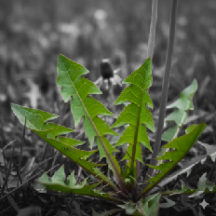
For Nature: The dandelion's leaves are a vital food source for a variety of wildlife, from rabbits and deer to the caterpillars of certain moths and butterflies. The serrated edges are a key identifying feature and are believed to have evolved to make them less appealing to some grazing animals, while the dense rosette of leaves helps the plant outcompete other plants for sunlight and water.
For Cooking: Young, tender dandelion greens are delicious raw in salads, offering a slightly bitter, peppery kick that stands in for arugula or endive. As the leaves mature, their bitterness increases, making them ideal for cooking. Sautéed with garlic and olive oil, they become a flavourful side dish, or they can be added to soups, stir-fries, and pasta to add a depth of flavour.
For Arts & Culture:
The common name "dandelion" comes from the French "dent de lion," or "lion's tooth," a vivid description of the leaves' deeply toothed shape. The leaves have also been used in textiles and art, representing resilience. The sheer abundance and powerful growth of the leaves, even in the most inhospitable environments, have made them a universal symbol of perseverance.
For Wellness: The leaves are a nutritional powerhouse, rich in vitamins A, C, and K, iron, and calcium. They are highly valued for their natural diuretic effect, helping the body shed excess fluid. Uniquely, they are naturally high in potassium, which helps replenish the minerals lost during this process. The leaves' bitter compounds are also traditionally believed to stimulate the appetite and support overall digestive health.
Dandelion Stems
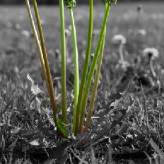
For Nature: The dandelion stem is a crucial, yet often overlooked, part of the plant's life cycle. It is a hollow stalk that rises from the center of the leaf rosette and is leafless. Its main function is to support the flower head, raising it high above the leaves to make it more accessible to pollinators. The hollow structure provides a lightweight yet strong support, and when broken, it exudes a milky white sap that acts as a deterrent to some pests.
For Cooking: While the stems are often discarded in many recipes, they can be used for a variety of purposes. The milky sap is quite bitter, but the stems themselves can be pickled to reduce this bitterness and add a unique crunch to dishes. Some adventurous cooks even use them to create infused syrups for cocktails, where the bitterness is balanced with sweetness.
For Arts & Culture: The hollow stalks are a classic material for making simple whistles or "horns," a beloved activity for children in many cultures. The flexibility of the stem also makes it ideal for weaving into chains and crowns, a simple yet beautiful tradition that connects generations through nature-based crafts. These playful uses of the stem are a testament to the dandelion's role as a symbol of childhood and creative expression.
For Wellness: The most noted wellness use of the dandelion stem is its milky white sap (latex). This sap is rich in compounds that, in traditional folk medicine, have been used externally to treat various skin irritations and ailments. It is a common anecdotal remedy for softening and clearing warts and calluses when applied directly and consistently over time. The sap's potential therapeutic properties are believed to come from its latex content and certain chemical compounds, but scientific evidence to support these traditional uses is limited.
Dandelion Roots
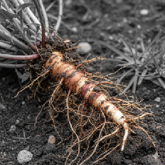
For Nature: The dandelion's root is a master of soil health. Its deep taproot breaks up compacted soil, creating channels for water and air. It acts as a natural aerator and brings up nutrients and minerals from deep in the earth, enriching the topsoil for other plants. These deep roots also provide a pathway for earthworms, further improving soil quality and structure.
For Cooking: Dandelion root has a distinct earthy, nutty flavour. When roasted and ground, it creates a popular caffeine-free coffee substitute. The fresh root can also be chopped and added to soups and stews, much like carrots or parsnips, where it adds a wholesome, grounding flavour.
For Arts & Culture: The dandelion's root, with its deep and tenacious hold, has become a powerful symbol in folklore and art. Its ability to thrive in a variety of conditions, even seemingly inhospitable ones, makes it a metaphor for resilience and endurance in many cultures. The long taproot has also been used in traditional crafts, such as weaving and basketry, where its strength and flexibility are prized. In some traditions, the root itself is seen as a connection to the earth's deep, hidden knowledge, symbolizing a grounded strength and a link to one's heritage.
For Wellness: The dandelion root has been used in traditional medicine for centuries, particularly as a liver tonic and for its diuretic properties, which may help with fluid retention and detoxification. It is rich in antioxidants and has been noted for its anti-inflammatory effects.
Promising Research for Cancer Cells: In early lab studies, dandelion root extract has been shown to encourage cancer cells to self-destruct. These studies suggest the extract can target and kill cancer cells without harming healthy cells.

Recipes

The Dandelion Recipe Collection: Herbal and Culinary


Dandelion Root Tea
For centuries, the dandelion root has been a staple in herbal medicine, primarily for its powerful detoxifying properties. This tea is lauded as a natural liver and kidney support. Brew a cup of Dandelion Root Tea to cleanse your system and enjoy a soothing drink that nourishes and strengthens your entire body.


Dandelion Root Tea
INGREDIENTS
- Fresh dandelion roots (enough to fill a small bowl)
- Water
BENEFITS
- Liver Health: May support liver function and bile production.
- Natural Diuretic: Acts as a natural diuretic to help with water retention and bloating.
- Digestive Aid: Can help stimulate appetite and soothe minor digestive issues.
- Rich in Antioxidants: Contains antioxidants that help protect your body's cells from damage.
- Anti-inflammatory: May have anti-inflammatory effects.
- Vitamins and Minerals: A good source of vitamin A, C, and K, and minerals such as iron and calcium.
Dandelion Root Tea
DIRECTIONS
- Harvest the Roots: Choose dandelions from a clean, pesticide-free area. Dig up the plants, trying to get as much of the root as possible.
- Clean and Wash: Thoroughly scrub the roots under running water to remove all dirt. You can use a vegetable brush for this. If you wish, you can also peel the outer skin, but it's not necessary.
- Chop: Dice the clean roots into small pieces.
- Roast: Spread the chopped roots in a single layer on a baking sheet. Roast them at 300°F (150°C) for 30-60 minutes. Stir them every 15 minutes. The roots are ready when they are dark brown, dry, and fragrant.
- Store: Once cooled, you can store in an airtight container.
- Brew: For each cup, use 1 to 2 teaspoons of the roasted dandelion roots. Steep in boiling water for 5-10 minutes. A tea infuser, ball, or pot works best, but you can also brew it like any other loose leaf tea.

Roasted Dandelion Root Coffee
If you love the dark, complex flavour of coffee but want to avoid the caffeine and acid, roasted dandelion root is the perfect substitute. This robust 'coffee' offers a rich, earthy flavour profile while simultaneously delivering powerful health benefits. Enjoy a satisfying, gut-friendly brew that supports your liver and provides a clean, sustained energy lift without the jitters or crash.


Roasted Dandelion Root Coffee
INGREDIENTS
- Fresh dandelion roots (enough to fill a small bowl)
- Water
BENEFITS
Liver Health: May support liver function and bile production.
Natural Diuretic: Acts as a natural diuretic to help with water retention and bloating.
Digestive Aid: Can help stimulate appetite and soothe minor digestive issues.
Rich in Antioxidants: Contains antioxidants that help protect your body's cells from damage.
Anti-inflammatory: Some compounds may have anti-inflammatory effects.
Vitamins and Minerals: A good source of vitamin A, C, and K, and minerals such as iron and calcium.
Roasted Dandelion Root Coffee
DIRECTIONS
- Harvest and Clean: Find dandelions in a clean, pesticide-free area. Dig up the plants, gathering as much of the root as you can. Thoroughly scrub the roots under running water to remove all soil.
- Chop: Dice the clean roots into small, uniform pieces, similar in size to coffee beans. This ensures they roast evenly.
- Roast: Spread the chopped roots in a single layer on a baking sheet. Roast in a preheated oven at 350°F (175°C) for 30-60 minutes, stirring occasionally. You're looking for the roots to become a deep, dark brown, almost black. They should be dry and emit a rich, nutty, and slightly bitter aroma.
- Grind (Optional): Once the roasted roots have cooled completely, you can grind them in a coffee or spice grinder. A coarse grind works well for a French press, while a finer grind is better for a drip coffee maker.
- Brew: Use your preferred brewing method (drip, French press, stovetop).

Dandelion Honey
Dandelion honey is a delightful way to capture the sweet, floral essence of the dandelion blossom in a versatile, spreadable form. Made by steeping the golden petals into a liquid and transforming it into a jelly or syrup, this recipe creates a vegan 'honey' with a flavour surprisingly similar to the real thing. It's a perfect topping for toast, a unique sweetener for tea, and a beautiful way to bring the taste of spring into your kitchen.

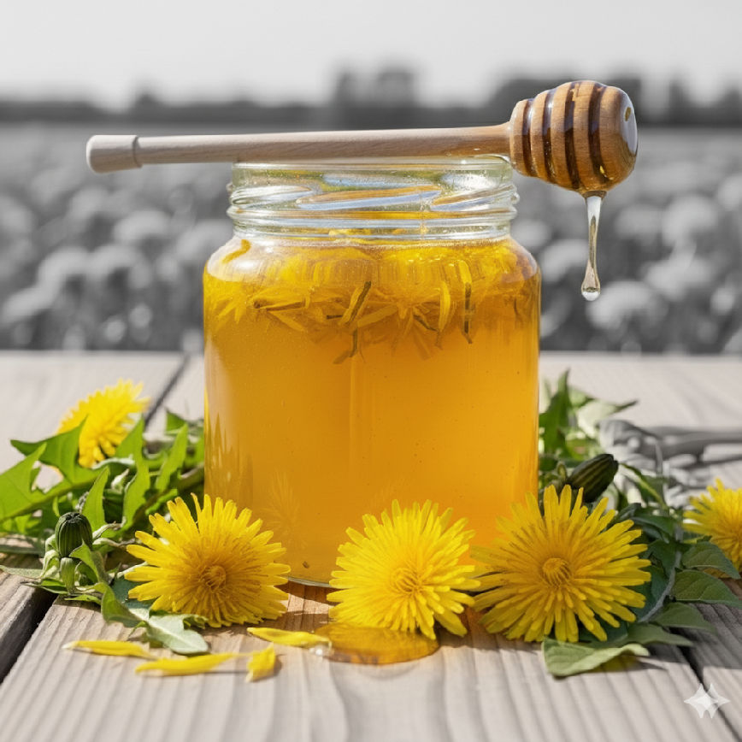
Dandelion Honey
INGREDIENTS
- 4 cups fresh dandelion flower heads (make sure they are pesticide-free)
- 4 cups water
- 3 slices of organic lemon
- 2 ½ cups sugar
USES
Sweetener for drinks (herbal teas or coffee)
Topping for breakfast (pancakes, oatmeal, yogurt)
Dessert drizzle (icecream, cake, fruit salads)
Glaze for savoury dishes (over roasted vegetables like carrots or parsnips)
Dressings for salads (combined with olive oil and vinegar)
Dandelion Honey
DIRECTIONS
- Prepare the Dandelions: Harvest dandelions on a sunny day when they are fully open. Gently shake the blossoms to remove any insects. You can use the entire flower head, but for a less bitter taste, use only the yellow petals.
- Infuse the Dandelion Tea: Place the dandelion flowers, water, and lemon slices in a saucepan. Bring to a boil, then reduce to a simmer for 20 minutes.
- Steep: Remove the saucepan from the heat, cover it, and let it steep for at least 6 hours, or ideally, overnight. This allows the flavours to fully infuse.
- Strain: The next day, strain the liquid through a fine-mesh sieve or a cheesecloth into a clean saucepan. Press down on the dandelion flowers to squeeze out all the liquid, then discard the solids.
- Create the Syrup: Add the granulated sugar to the saucepan with the dandelion liquid. Bring it to a boil, stirring until the sugar is completely dissolved.
- Simmer and Thicken: Reduce the heat to a low simmer and cook, uncovered, for 45 to 60 minutes, or until the liquid has reduced and thickened to a syrupy consistency. It will thicken more as it cools, so be careful not to overcook it.
- Store: Carefully pour the hot dandelion honey into clean, sterilized jars. Seal tightly and store in the refrigerator. It should keep for several weeks.

Dandelion Lollipops
Dandelion Lollipops are a delightful, whimsical treat that captures the bright, mild flavour of the dandelion blossom in a hard candy form. These lollipops make foraging fun and are a perfect way to introduce children to wild edibles. They also provide a soothing, all-natural option for a sore throat, making them both a sweet confection and a useful herbal remedy to keep on hand.


Dandelion Lollipops
INGREDIENTS
- Dandelion Root Tea (See steps 1-4 in our dandelion root tea recipe)
- Sugar
- A candy thermometer
- Lollipop sticks or candy molds
DIRECTIONS
(Skip to #5 if you have completed directions 1-4 in our dandelion root tea recipe to create the strained dandelion liquid)
- Harvest the Roots: Choose dandelions from a clean, pesticide-free area. Dig up the plants, trying to get as much of the root as possible.
- Clean and Wash: Thoroughly scrub the roots under running water to remove all dirt. You can use a vegetable brush for this. If you wish, you can also peel the outer skin, but it's not necessary.
- Chop & Roast: Chop clean roots into small pieces and spread in a layer onto a baking sheet. Roast them at 300°F.
- Combine the liquid: In a saucepan, add the strained dandelion liquid with an equal amount of sugar.
- Dissolve the sugar: Add the sugar to the strained liquid and stir until it dissolves completely over medium-low heat.
- Boil the mixture: Increase the heat to medium-high and bring to a boil without stirring. Clip a candy thermometer to the side of the pan.
- Reach hard-crack: Boil until the thermometer reads 300-310∘F (149-154∘C), which is the "hard-crack" stage. Then, remove from the heat.
- Pour the mixture: Carefully pour the hot liquid into a silicone lollipop mold or onto a parchment-lined baking sheet. Insert lollipop sticks, if desired.
- Cool and remove: Cool completely before removing them from the molds.

Dandelion Wine
Dandelion Wine is perhaps the most celebrated and romanticized of all dandelion recipes. Far from a passing fad, this is an ancient recipe, known for producing a light, floral, and surprisingly dry wine that perfectly embodies the taste of spring. Making it is a rewarding, multi-day process that requires patience, but the final, golden-hued vintage is a beautiful testament to the simple bounty of the wild.


Dandelion Wine
INGREDIENTS
- Dandelion Petals: (1 to 2 gallons, loosely packed)
- Water: (as needed)
- Organic Cane Sugar: (4-8 cups per gallon of water)
- Oranges and/or Lemons: (for zest and juice)
- Vegan Wine Yeast: One packet of a Lalvin strain, such as Lalvin EC-1118
- Optional Additions: Raisins, vegan yeast nutrient, agave nectar, or dandelion honey
NOTES
For vegan winemaking, avoid fining agents like gelatin, casein, or isinglass (fish bladder), as these are animal-based. Dandelion wine will generally clear on its own with time and racking, but if you need to speed up the process, plant-based fining agents like bentonite clay or Irish moss are suitable alternatives.Winemaking requires careful sanitation of all equipment to prevent contamination and spoilage.
Dandelion Wine
DIRECTIONS
- Preparation: Harvest dandelion flowers from a pesticide-free area. Carefully remove all green parts and stems, using only the yellow petals.
- Making the Must: Place the petals in a large pot. Pour boiling water over them and let them steep for 24-48 hours to extract full flavour.
- Boil & Sweeten: Strain out the petals. Return the liquid to a boil and stir in the organic cane sugar, citrus zest, and juice until dissolved.
- Fermentation: Once the liquid has cooled to about 90°F, add one packet of Lalvin EC-1118 yeast. Transfer to a sanitized fermenter and fit it with an airlock. Fermenter options might include: a glass carboy, food-grade plastic bucket, glass gallon jugs, or a stainless steel fermenter.
- Racking & Clarifying: Ferment until bubbling stops. Carefully siphon the clear wine into a new container, leaving the sediment behind. Repeat as needed until the wine is clear.
- Bottle & Age: Bottle the clear wine and store in a cool, dark place. The flavour improves significantly with aging, so let it rest for at least 6 months to a year before enjoying.

Dandelion Green Salad
A fresh salad featuring dandelion greens is arguably the fastest and most nutrient-dense way to consume this superfood. While the young greens offer a pleasant, slightly bitter snap, the bitterness is easily balanced with a bright, sweet vinaigrette and complementary ingredients like citrus segments, non-dairy cheese, or toasted nuts. This simple salad is a powerhouse of vitamins and a fantastic, vibrant, and fully plant-based addition to your daily meal plan.


Dandelion Green Salad
INGREDIENTS
- 4 cups young dandelion greens, washed and dried
- 1/4 cup toasted walnuts or pecans
- 1/4 cup crumbled vegan feta or nutritional yeast
FOR THE VINAIGRETTE
- 3 tbsp extra virgin olive oil
- 1 tbsp fresh lemon juice
- 1 tsp dandelion honey (or maple syrup)
- Salt and black pepper to taste
TIP
Consider adding fresh or dried fruit. The natural sweetness of ingredients like sliced strawberries, pears, or dried cranberries provides a beautiful contrast to the peppery bitterness of the greens.

Sautéed Dandelion Greens
Sautéing is one of the quickest and most popular ways to enjoy mature dandelion greens, as the heat helps to soften their texture and tame their natural bitterness. A quick flash in a hot pan with a splash of olive oil and a touch of acid, like lemon juice or vinegar, transforms them into a savoury, slightly smoky side dish. This method is an excellent, simple way to incorporate the powerful nutritional benefits of the greens into any weeknight meal.

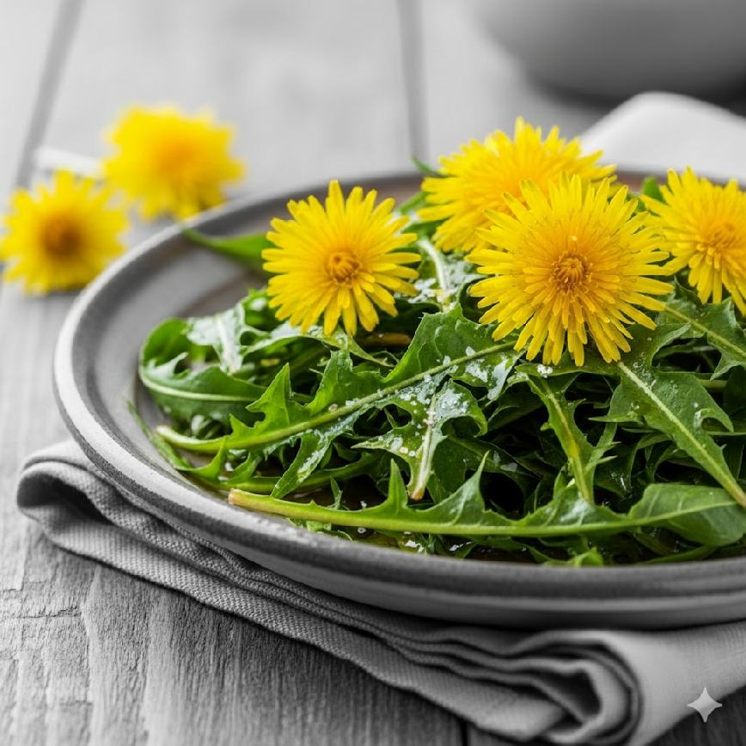
Sautéed Dandelion Greens
INGREDIENTS
- 4 cups dandelion greens, washed and well-dried
- 2 tbsp olive oil
- 2-3 cloves garlic, thinly sliced
- Salt and black pepper to taste
TIPS
Flavour Boost: Finish the dish with a splash of balsamic vinegar for a tangy kick or a teaspoon of tamari for a salty, umami flavour. A pinch of red pepper flakes adds a nice touch of heat.
Texture and Crunch: Stir in some toasted pine nuts or sliced almonds right before serving. You could also sprinkle the dish with crispy, pan-fried garlic chips.
Sweetness: A handful of dried cranberries or raisins can balance the bitterness of the greens. For a truly unique flavour, drizzle a teaspoon of your dandelion honey over the finished dish.

Sautéed Dandelion Greens
DIRECTIONS
- Heat the olive oil in a large skillet over medium heat. Add the sliced garlic and red pepper flakes (if using) and cook for about 1 minute, until fragrant but not browned.
- Add the dandelion greens to the skillet. They will look like a lot at first, but they will quickly wilt down.
- Sauté the greens for 3-5 minutes, stirring often, until they are tender and have reduced significantly in size.
- Season with salt and pepper to taste.
- Serve immediately as a side dish.

Dandelion Root Gravy
Dandelion Root Gravy is a savoury, ingenious way to use the roasted root in a warm, comforting side. When finely chopped and sautéed, the roots lend a deep, earthy, and slightly woodsy flavour that gives this vegan gravy a complexity often missing in mushroom-only sauces. Perfect poured over mashed potatoes, lentil loaves, or biscuits, this recipe transforms the root into a hearty, foundational savoury condiment.

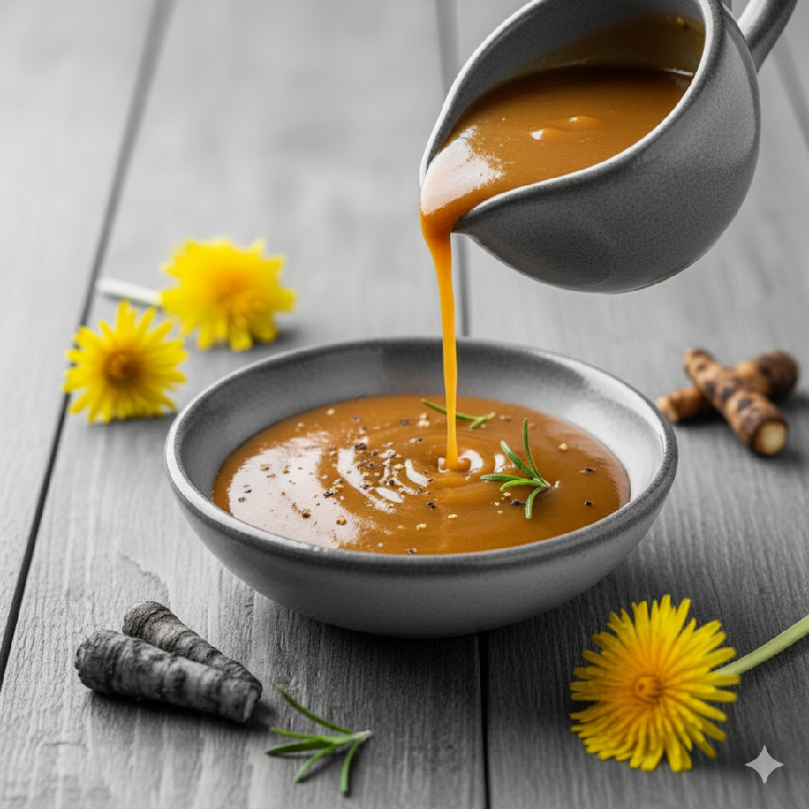
Dandelion Root Gravy
INGREDIENTS
- 1 tbsp vegan butter or more olive oil
- 1 onion, finely chopped
- 1/2 cup chopped, roasted dandelion root
- 2 tbsp all-purpose flour
- 2 cups vegetable broth
- 1 tbsp fresh thyme leaves
USES
Vegetables (sautéed mushrooms, roasted asparagus, steamed green beans)
Starches (mashed potatoes, roasted root vegetables like carrots or parsnips
Plant based protein (seared tempeh or pan-fried tofu)
Dandelion Root Gravy
DIRECTIONS
- Season the mushrooms with salt and pepper. In a large skillet, heat the olive oil over medium-high heat. Cook the mushrooms until they are golden brown and have released their moisture. Remove the mushrooms from the skillet and set aside.
- In the same skillet, melt the vegan butter over medium heat. Add the onion and roasted dandelion root. Cook until the onion is soft and the roots are fragrant.
- Sprinkle the flour over the vegetables and stir for one minute. Slowly pour in the vegetable broth, stirring constantly to avoid lumps. Bring to a simmer and cook until the gravy thickens.
- Stir in the fresh thyme. Return the mushrooms to the skillet and spoon the gravy over them. Serve warm.

Dandelion Flower Fritters
Dandelion Flower Fritters transform the bright yellow blossoms into a delicious, warm, cake-like treat. This simple, fully plant-based recipe uses the flowers to infuse the batter with a delicate, honey-like flavour that is truly unique to spring foraging. Light and crispy on the outside, and soft on the inside, these fritters are the perfect dessert, brunch item, or special snack, especially when drizzled with maple syrup.


Dandelion Flower Fritters
INGREDIENTS
- 2 cups fresh dandelion flowers (make sure they are pesticide-free)
- 1 cup all-purpose flour
- 1 tbsp sugar
- 1/2 tsp baking powder
- Pinch of salt
- 1 cup plant-based milk (almond, soy, or oat)
- 1 flax egg (1 tbsp ground flaxseed mixed with 3 tbsp water, set for 5 minutes)
- Cooking oil for frying
- Maple syrup for drizzling
USES
Classic Drizzle: With a generous drizzle of maple syrup.
Powdered Sugar: Dust the warm fritters with powdered sugar.
Fruit Topping: Fresh berries, a scoop of fruit compote, or a dollop of applesauce.
Dandelion Flower Fritters
DIRECTIONS
- Prepare the Dandelions: Gently rinse the fresh dandelion flowers. Shake off excess water and make sure they are completely dry before proceeding.
- Make the Flax Egg: In a small bowl, combine 1 tbsp of ground flaxseed with 3 tbsp of water. Stir well and let it sit for at least 5 minutes, or until it has a gelatinous, egg-like consistency.
- Mix Dry Ingredients: In a medium bowl, whisk together the all-purpose flour, sugar, baking powder, and salt.
- Combine Wet Ingredients: Add the plant-based milk and the prepared flax egg to the dry ingredients. Whisk until the batter is smooth and a little lumpy, but do not over-mix. The batter should be thick enough to coat the dandelion flowers.
- Heat the Oil: Pour about an inch of cooking oil into a large skillet or pan. Heat the oil over medium-high heat until it shimmers. To test if it's ready, drop a small amount of batter into the oil; it should sizzle immediately.
- Coat and Fry: Holding a dandelion flower by its stem, dip it into the batter, ensuring it's completely coated. Gently place the battered flower into the hot oil. Repeat with a few more flowers, being careful not to overcrowd the pan.
- Cook: Fry the fritters on each side, or until they are golden brown.
- Drain Excess Oil: Carefully remove the fritters from the pan and place them on a paper towel-lined plate to drain any excess oil.
- Serve: Serve the dandelion flower fritters immediately while they are still warm. Drizzle with maple syrup for a delicious treat.

Uses

More Than Just Food: Gardening, Crafts, and Culture


More Than Just Food
You’ve already discovered just how delicious and nutritionally potent the dandelion can be in your kitchen. But the true story of this humble plant extends far beyond the plate, moving from the culinary to the profoundly useful. If you thought its value peaked in a salad or a coffee substitute, prepare to be surprised again.

In this chapter, we delve into the dandelion's other remarkable talents, exploring its surprising uses for your home, garden, and even your creative spirit. We’ll show you how this resilient little plant can act as a natural soil engineer that enhances your planting beds, how its sunny blooms can inspire unique crafts and homemade items, and how its existence connects you to centuries of global folklore and forgotten cultural traditions.
Get ready to appreciate the dandelion not as a weed, but as a multipurpose ally in your home ecosystem. By the end of this chapter, you’ll understand why generations of people have valued the dandelion and why it deserves a celebrated place in your life.
Gardening
The dandelion's resilience isn't just a survival trait; it's a powerful benefit for your entire garden ecosystem. By intentionally integrating dandelions, you invite a hardworking, multifunctional powerhouse into your garden that does the heavy lifting for your soil and plants.

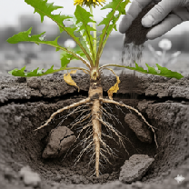
Soil Improvement: Dandelions possess a remarkably strong and deep taproot—often extending 10 to 15 feet down! This root system works like a natural tiller, physically breaking up compacted soil, clay, and hardpan layers. By creating channels, they dramatically improve aeration and drainage, allowing water and oxygen to penetrate deeper. As these roots naturally age and decompose, they leave behind valuable organic matter and deposit essential minerals and nutrients back into the topsoil, essentially acting as a form of slow-release, natural fertilizer.

Forage Crop: Beyond your own table, dandelions are a highly nutritious food source for many animals. Their greens and flowers are eagerly consumed by horses, deer, rabbits, and many ground-dwelling insects. Allowing a small, pesticide-free patch to grow is a simple, effective way to support local biodiversity.
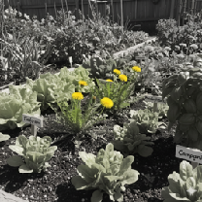
Companion Planting: Some experienced gardeners purposefully use dandelions as companion plants. The plant's deep roots function as a "nutrient pump," drawing essential minerals—most notably calcium, magnesium, and iron—up from the subsoil. These nutrients are then stored in the leaves, and when the leaves drop, are broken down, or decompose, they become available to the surrounding, shallower-rooted garden vegetables.
Did You Know?
Planting dandelions near fruiting plants is especially beneficial, particularly for crops like tomatoes, strawberries, melons, and squash.
Arts & Crafts
The dandelion offers surprising versatility, transforming from a garden plant into a resource for creative projects, household utility, and even industrial innovation.

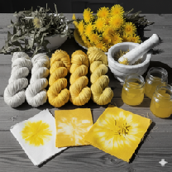
Natural Dyes and Pigments: The bright gold of the dandelion is easily captured. The flowers can be used to create a vibrant yellow dye for naturally colouring wool, fabrics, and other materials. Additionally, the crushed petals can be mixed with a binding agent to create unique natural pigments used by artists in watercolours or oil paints.
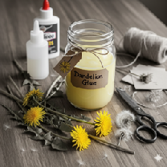
Natural Glue: The milky, sticky sap found inside a broken dandelion stem is, surprisingly, a form of natural latex glue. For small, immediate repairs or crafts, simply break a stem and dab the sap directly onto your project. For more substantial needs, you can even cook the entire dandelion plant to extract and concentrate more of this natural adhesive for larger batch projects.

Art and Literature: Dandelions are a frequent and powerful subject in art, poetry, and literature. They typically serve as a metaphor for innocence, the fleeting nature of life, resilience, and the simple beauty of nature. The iconic seed head—the "puffball"—holds a particularly potent cultural role, symbolizing wishes, hope, and the universal experience of letting go, connecting people across generations through the simple act of blowing the seeds into the wind.

Rubber Production: Perhaps the most surprising use is in industry. The Russian dandelion is a specific species that produces high-quality latex in its roots. It has been studied globally as a crucial potential source of natural rubber. This makes the dandelion a valuable strategic crop for creating products ranging from sustainable tires to essential medical products such as latex gloves, catheters, and other specialized materials.
Culture
Across centuries and continents, the dandelion has embedded itself into human culture, moving from a prized medicinal herb to a powerful symbol of resilience and hope.
Folklore and Wishes: The most universally known cultural use is the tradition of blowing on the mature seed head, the "puffball," while making a wish. This simple, cherished act of childhood represents hope, wishes sent to the wind. Historically, dandelions were also used in various folk practices for everything from weather forecasting (it closes before rain) to determining romantic fortunes. The act of letting the seeds fly connects us to generations who saw the dandelion as a link between earth and aspiration.
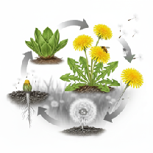
Symbolism: Dandelions represent resilience, perseverance, and the ability to thrive in challenging circumstances—a vibrant spot of gold insisting on life. The flower's life cycle—from a bright yellow bloom to a delicate, wind-borne seed head—symbolizes transformation, growth, and the cyclical nature of life. It reminds us that when our structure changes, our essence can still be potent and far-reaching.
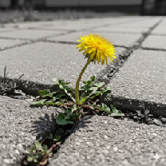
Cultural Representation: The dandelion's unique strength has led to its adoption in modern culture as well. The dandelion is the official flower of the military child, symbolizing their inherent resilience, adaptability, and ability to thrive no matter where they are planted. It serves as a beautiful tribute to their steadfast nature amidst constant change.
Did You Know?
The very word "dandelion" is a shortened, corrupted version of the French phrase "dent de lion," meaning "lion's tooth." This name, which dates back to medieval times, was inspired by the characteristic jagged, tooth-like shape of the leaves, highlighting that people have been observing and naming this plant based on its distinct features for hundreds of years.
Thanks for Reading!
As our story comes to an end, the dandelion's journey continues—sending seeds out into the world on the whisper of a breeze. Carrying the potential for new life, new growth, and a new chance to begin again.
Thank you for taking the time to discover the quiet strength of this humble plant, and its incredible gifts it offers. From its deep roots that nurture the soil to its bright flowers that feed the bees, the dandelion is a perfect example of how much good can come from a simple act of existing. We encourage you to carry the knowledge of the dandelion with you. Resist the urge to dismiss the "common," and look close to find true value. Practice the golden connection by allowing the first golden blooms to fuel the spring pollinators.
May you remember the smallest things can leave the biggest impact, and that true strength is often found in unexpected places. The next time you see a field of dandelions, I hope you see a testament to the beauty and power that lies within all of us.
The Honest Whisper


